Solve each of the following using an equation. Be sure to show all work and label your final answers.

1) Mary is at a basketball game and 2) Mary has $40.00 to spend at the
would like to buy 2 hot dogs and 2 basketball game. How much change
sodas. A hot dog costs $6.75 and a does Mary have after she has
soda costs $4.00. How much money purchased the food? (Use your
will Mary spend? answer from #3 to help you solve)

3) Sammy and Erin are going to a 4) Together, Sammy and Erin have
Raven’s game. Tickets cost $76.50 each $200.00 to spend at the football game.
and the one parking pass is $10.50. How much change do they have
How much money have they spent so far? after paying for parking and tickets?
(Use your answer from #3 to help you solve)

5) 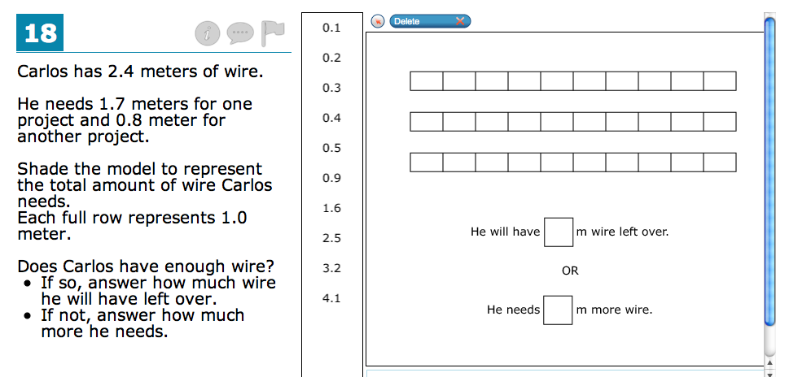

(Hint for #6: use rectangles and refer to your journal)
6) Draw It Out:

7) Your family made 3 ¾ cups of ice cream before the family sits down to watch a movie. How big is the family if each person receives 5/8 cups of ice cream? Show all work and explain how you determined your answer using an expression or equation.

