1) Create a scenario to represent the following equation: (16) + (-16) = 0

2) A city in the continent of Africa is located 4° north of the equator. What is the location in degrees longitude that is the same distance south of the equator?
__________
3) Choose one scenario below and explain the value of +8 and -8 in terms of the situation.
- Temperature Change
- Change in elevation
- Money in your bank account

4) The number 4 is located 10 spaces to the right on a number line of what number? _____________

5) Part I: Place the following symbols on the number line below based upon their clues.
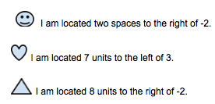

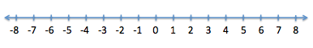
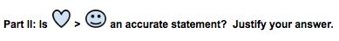

__________________________________________________________________________________

__________________________________________________________________________________

6) Describe -14 < -6 as it relates to locations on a number line.

______________________________________________________________________

______________________________________________________________________

7) The following inequality statement represents the profit and loss of two different local snowball stands. Icy Snowball Stand generated a $27 profit this month while Freeze It Snowball Stand generated a loss of $35. Write an inequality statement to describe this situation and explain what the inequality means in terms of profit and loss.
__________________

8) List two numbers that are the same distance from zero. _______ _______

Write each of the scenarios as integers and its opposite:
9) $78 drop in sales ____________ _____________
10) windchill of 17 degrees below zero ____________ _____________
11) Order the following numbers 17, -12, 9, -26, 0 from least to greatest.
____________________________
12) Compare using <, >, and =.

-5 _____ 2 -17 _____ -6 8 _______ -8

13) Graph the following five numbers on a number line; then order the numbers from greatest to least:

