**6.EE.1 Passport for Around the World**

|  |  |
| --- | --- |
| **Name:**  **Date:**  **Period:** | **1. Paris** |
| **2. London** | **3. Dublin** |
| **4. Grand Canyon** | **5. New York** |
| **6. Niagara Falls** | **7. Costa Rica** |
| **8. Egypt** | **9. Beijing** |
| **10. Puerto Rico** | **11. Chicago** |
| 1. **San Francisco** | **j0189205**  **You did it!!!** |

Order of Operations with Exponents



Around the World

**Paris**





**London**





**Dublin**





**Grand Canyon**





**New York**





**Niagara Falls**





**Costa Rica**

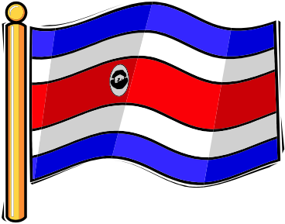



**Egypt**

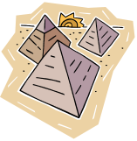



**Beijing**

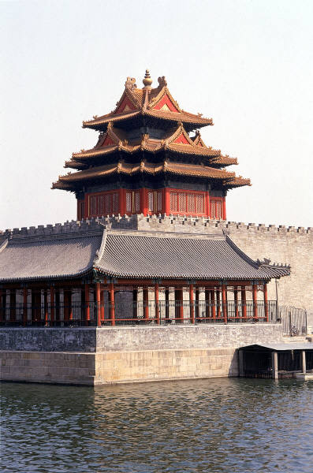



**Puerto Rico**

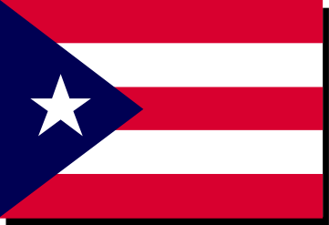



**Chicago**





**San Francisco**



